Солодонова Виктория, 141-361

Запросы к базе данных «Ювелирная Мастерская»

список изделий, которые продали или вернули

select ID_PRODUCT, P_NAME, DATE_OF_SALE, COST, R_SPECIFICATION

FROM PRODUCT PR

JOIN RELATION_7V1 PS

ON PR.ID_PRODUCT = PS.PRODUCT_ID_PRODUCT

JOIN SELLING SE

ON PS.SELLING_ID_SELLING = SE.ID_SELLING

JOIN REFUND RE

ON RE.ID_REFUND = SE.REFUND_ID_REFUND

ORDER BY RE.ID_REFUND

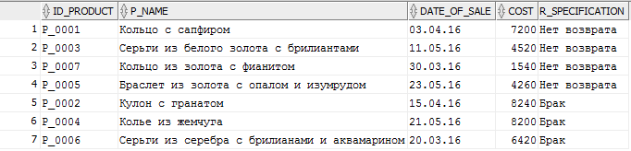

список брака

select ID_PRODUCT, P_NAME, DATE_OF_SALE, COST, R_SPECIFICATION

FROM PRODUCT PR

JOIN RELATION_7V1 PS

ON PR.ID_PRODUCT = PS.PRODUCT_ID_PRODUCT

JOIN SELLING SE

ON PS.SELLING_ID_SELLING = SE.ID_SELLING

JOIN REFUND RE

ON RE.ID_REFUND = SE.REFUND_ID_REFUND

WHERE RE.ID_REFUND = 'Re_02'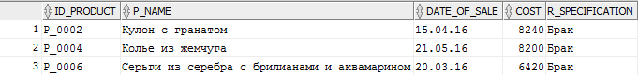

самые популярные изделия за месяц

select ID_PRODUCT, P_NAME, DATE_OF_SALE

FROM PRODUCT PR

JOIN RELATION_7V1 PS

ON PR.ID_PRODUCT = PS.PRODUCT_ID_PRODUCT

JOIN SELLING SE

ON PS.SELLING_ID_SELLING = SE.ID_SELLING

WHERE DATE_OF_SALE BETWEEN '21.10.2010' AND '06.04.2016'

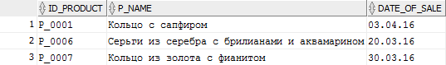

список мастеров у которых больше всего возвратов изделий

select R_SPECIFICATION, M_SURNAME,ID_PRODUCT, P_NAME, DATE_OF_SALE, COST

FROM PRODUCT PR

JOIN RELATION_7V1 PS

ON PR.ID_PRODUCT = PS.PRODUCT_ID_PRODUCT

JOIN SELLING SE

ON PS.SELLING_ID_SELLING = SE.ID_SELLING

JOIN MASTER MA

ON PR.MASTER_ID_MASTER = MA.ID_MASTER

JOIN REFUND RE

ON RE.ID_REFUND = SE.REFUND_ID_REFUND

WHERE RE.ID_REFUND = 'Re_02'

ORDER BY M_SURNAME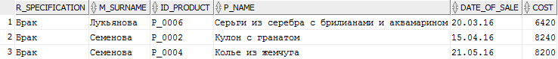

список самых частых причин возврата

SELECT REFUND_ID_REFUND,COUNT(REFUND_ID_REFUND) FROM SELLING

GROUP BY REFUND_ID_REFUND

ORDER BY REFUND_ID_REFUND



квитанции

select ID_SELLING, C_SURNAME,P_NAME, DATE_OF_ORDER, DATE_OF_SALE, COST, M_SURNAME

FROM SELLING SE

JOIN CLIENT CL

ON CL.ID_CLIENT = SE.CLIENT_ID_CLIENT

JOIN RELATION_7V1 SP

ON SE.ID_SELLING = SP.SELLING_ID_SELLING

JOIN PRODUCT PR

ON SP.PRODUCT_ID_PRODUCT = PR.ID_PRODUCT

JOIN MASTER MA

ON PR.MASTER_ID_MASTER = MA.ID_MASTER

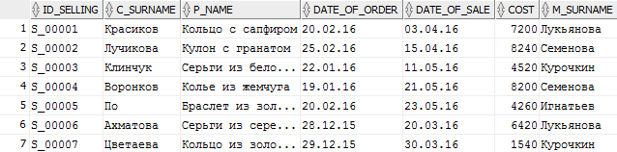

выручка и средняя стоимость за определенный период

SELECT SUM(COST)

FROM SELLING

WHERE DATE_OF_SALE BETWEEN '01.04.2016' AND '30.06.2016'

SELECT AVG(COST)

FROM SELLING

WHERE DATE_OF_SALE BETWEEN '01.04.2016' AND '30.06.2016'

Список материалов в изделиях

select P_NAME, MAT_NAME

FROM PRODUCT PR

JOIN RELATION_4 RN

ON PR.ID_PRODUCT = RN.PRODUCT_ID_PRODUCT

JOIN COMPOSITION COM

ON RN.COMPOSITION_ID__COMPOSITION = COM.ID__COMPOSITION

JOIN MATERIAL ML

ON COM.MATERIAL_ID_MATERIAL = ML.ID_MATERIAL

ORDER BY PR.P_NAME

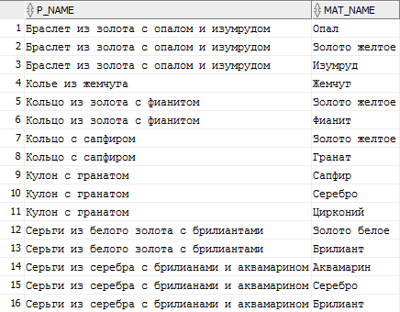

Кольца и список материалов

select P_NAME, MAT_NAME

FROM PRODUCT PR

JOIN RELATION_4 RN

ON PR.ID_PRODUCT = RN.PRODUCT_ID_PRODUCT

JOIN COMPOSITION COM

ON RN.COMPOSITION_ID__COMPOSITION = COM.ID__COMPOSITION

JOIN MATERIAL ML

ON COM.MATERIAL_ID_MATERIAL = ML.ID_MATERIAL

WHERE TYPE = 'Кольцо'

ORDER BY PR.P_NAME

